CPE301 – SPRING 2019

Design Assignment 2A

Student Name: Tyler Gardenhire

Student #: 8000450294

Student Email: gardenhi@unlv.nevada.edu

Primary Github address: [gardenhi@unlv.nevada.edu](mailto:gardenhi@unlv.nevada.edu)

Directory: https://github.com/tylergardenhire/submission_projects.git

Submit the following for all Labs:

1. In the document, for each task submit the modified or included code (only) with highlights and justifications of the modifications. Also, include the comments.
2. Use the previously create a Github repository with a random name (no CPE/301, Lastname, Firstname). Place all labs under the root folder ESD301/DA, sub-folder named LABXX, with one document and one video link file for each lab, place modified asm/c files named as LabXX-TYY.asm/c.
3. If multiple asm/c files or other libraries are used, create a folder LabXX-TYY and place these files inside the folder.
4. The folder should have a) Word document (see template), b) source code file(s) and other include files, c) text file with youtube video links (see template).

1. **COMPONENTS LIST AND CONNECTION BLOCK DIAGRAM w/ PINS**

Atmel Studio 7 w/ AVR assembly and simulator and Atmega328p board used.

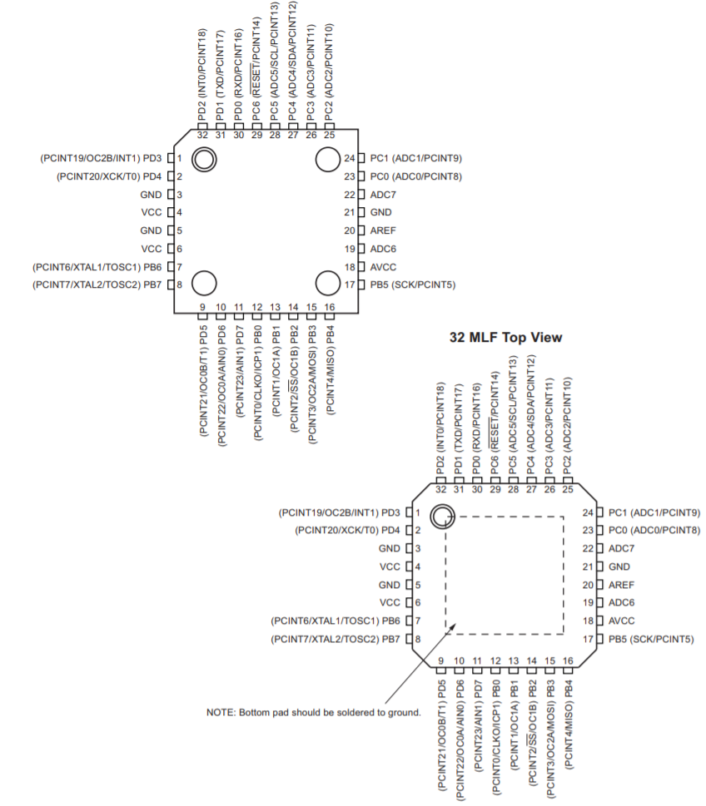

PortB2 is connected to LED3 and PortC2 is connected to SW1.

1. **INITIAL/MODIFIED/DEVELOPED CODE OF TASK 1/A**

Task 1 Assembly Code:

.org 0

sbi ddrb, 2 ;set portb2 as output

ldi r20, 5

sts tccr1b, r20 ;set clock prescaler to 1024

begin: sbi portb, 2 ;set portb2 to high

ldi r21, 0x00

sts tcnt1h, r21 ;set high bits of timer to 0

sts tcnt1l, r21 ;set low bits of timer to 0

rcall delayon ;call first delay function

cbi portb, 2 ;clear portb2

ldi r21, 0x00

sts tcnt1h, r21 ;set high bits of timer to 0

sts tcnt1l, r21 ;set low bits of timer to 0

rcall delayoff ;call second delay function

rjmp begin ;infinite loop

delayon:

lds r29, tcnt1h ;load high bits of timer1

lds r28, tcnt1l ;load low bits of timer1

cpi r28, 0xa9 ;compare low bits of timer1 to 0x01a9 (representing 0.435 seconds)

brsh bodyon

rjmp delayon

bodyon:

cpi r29, 0x01 ;compare high bits of timer1 to 0x01a9

brlt delayon

ret

delayoff:

lds r29, tcnt1h ;load high bits of timer1

lds r28, tcnt1l ;load low bits of timer1

cpi r28, 0x1b ;compare low bits of timer1 to 0x011b (representing 0.290 seconds)

brsh bodyoff

rjmp delayoff

bodyoff:

cpi r29, 0x01 ;compare high bits of timer1 to 0x01a9

brlt delayoff

ret

Task 1 C Code:

#include <avr/io.h> //standard avr library

#define *F_CPU* 1000000UL //set clock speed in MHz

#include <util/delay.h> //delay library for above clock speed

int main(void)

{

DDRB |= (1 << PB2); //define portb2 as an output to blink the LED

while(1) //infinite loop to see the correct output on the board

{

PORTB |= (1 << PB2); //turn led ON

*_delay_ms*(435); //delay for 435ms

PORTB &= ~(1 << PB2); //turn led OFF

*_delay_ms*(290); //delay for 290ms

}

1. **DEVELOPED MODIFIED CODE OF TASK 2/A from TASK 1/A**

Task 2 Assembly Code:

.org 0

cbi ddrc, 2 ;set portc2 as input (switch)

sbi ddrb, 2 ;set portb2 as output (led)

ldi r20, 5

sts tccr1b, r20 ;set clock prescaler to 1024

again: sbic pinc, 2 ;check if portc2 is receiving input from switch

rjmp over ;if so, jump to over

cbi portb, 2 ;if not, clear portb2

rjmp again ;infinite loop

over: sbi portb, 2 ;set portb2 to high

ldi r21, 0x00

sts tcnt1h, r21 ;set high bits of timer1 to 0

sts tcnt1l, r21 ;set low bits of timer1 to 0

rjmp delayon ;jump to delay (1.25 second delay)

rjmp again ;infinte loop

delayon:

lds r29, tcnt1h ;load high bits of timer1

lds r28, tcnt1l ;load low bits of timer1

cpi r28, 0xc5 ;compare low bits of timer1 to 0x04c5 (representing 1.25 seconds)

brsh bodyon

rjmp delayon

bodyon:

cpi r29, 0x04 ;compare high bits of timer1 to 0x04c5

brlt delayon

ret

Task 2 C Code:

#include <avr/io.h> //standard avr library

#define *F_CPU* 1000000UL //set clock speed in MHz

#include <util/delay.h> //delay library for above clock speed

int main(void)

{

DDRB |= (1 << PB2); //define portb2 as an output to blink the LED

DDRC &= (0 << PB2); //define portc2 as an input (switch)

PORTC |= (1 << PB2); //enable pull-up

while(1) //infinite loop

{

if (PINC) //if there is input at portc2

{

PORTB |= (1 << PB2);//enable portb2

*_delay_ms*(1250); //delay for 1.25 seconds

}

else

PORTB &= ~(1 << PB2); //else clear portb2

}

return 1;

}

1. **SCHEMATICS**

N/A

1. **SCREENSHOTS OF EACH TASK OUTPUT (ATMEL STUDIO OUTPUT)**

Task 1:

Assembly:

725 ms * 60% duty cycle = 435 ms, the following screenshot was taken at end of first delay call.

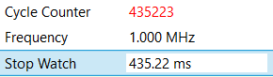

Full period is 725 ms, the following screenshot was taken at the end of one loop.

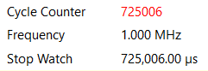

C:

The following screenshot was taken at end of first delay call.

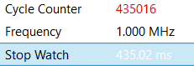

Full period is 725 ms, the following screenshot was taken at the end of one loop.

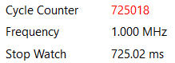

Task 2:

Assembly:

Full period is 1.25 s, the following screenshot was taken at the end of one loop.

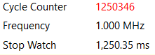

C:

Full period is 1.25 s, the following screenshot was taken at the end of one loop.



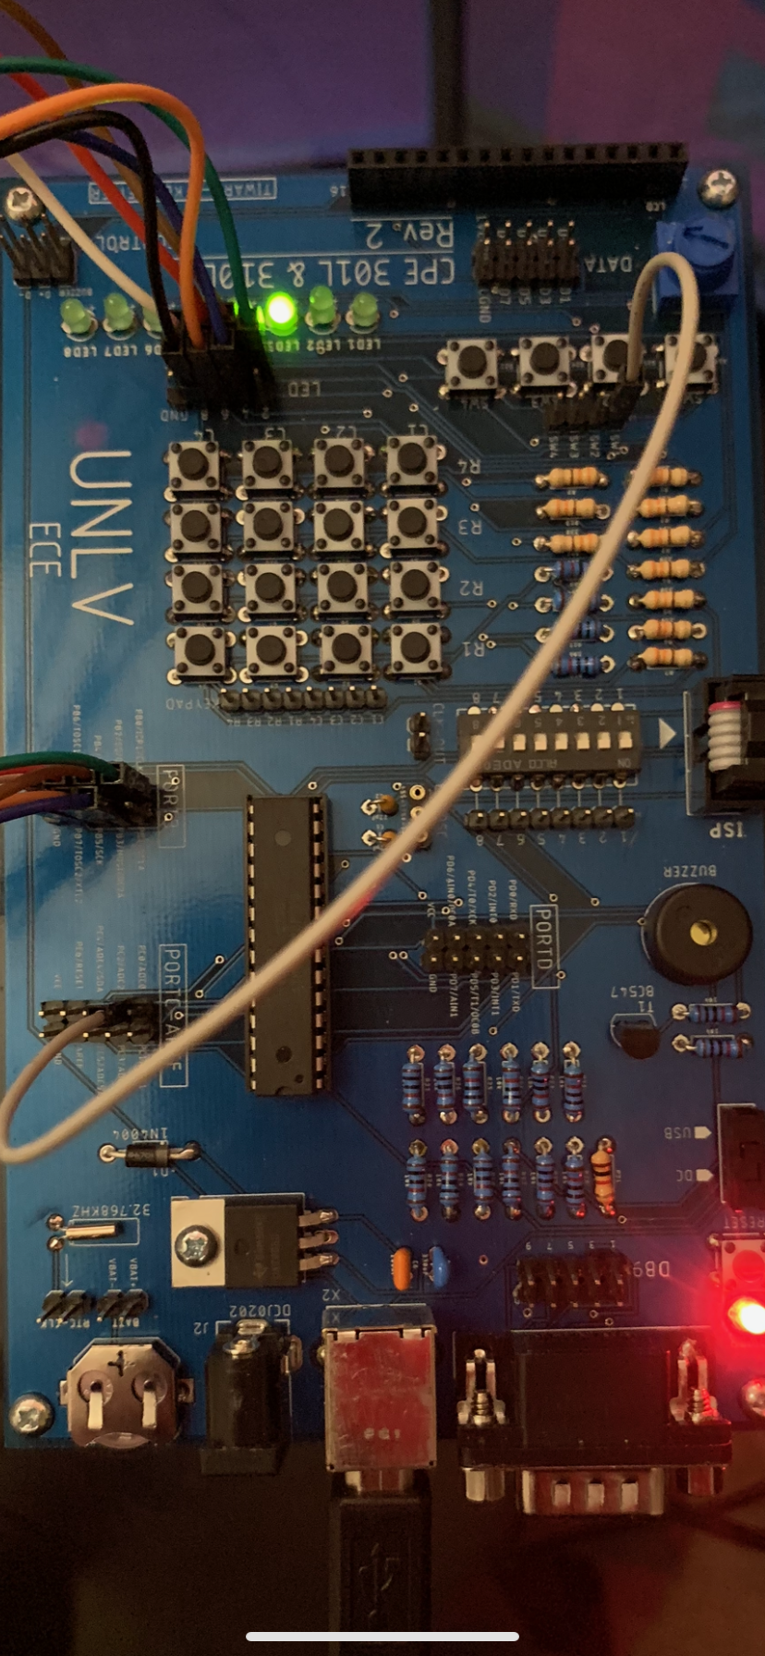

1. **SCREENSHOT OF EACH DEMO (BOARD SETUP)**
2. **VIDEO LINKS OF EACH DEMO**

https://youtu.be/PYId6ZwDTrc

1. **GITHUB LINK OF THIS DA**

https://github.com/tylergardenhire/submission_projects.git

**Student Academic Misconduct Policy**

<http://studentconduct.unlv.edu/misconduct/policy.html>

“This assignment submission is my own, original work”.

TYLER GARDENHIRE